
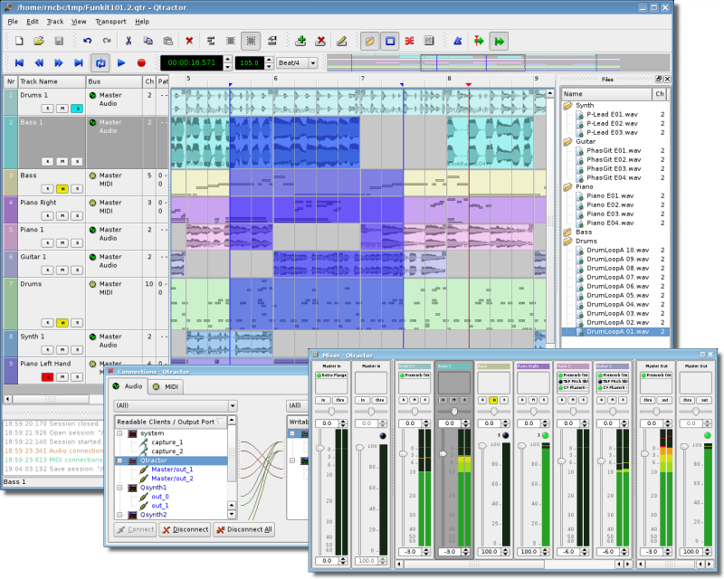

Qtractor

Linux Audio and MIDI
Multi-Track Workstation

Version 0.1.2

Frantic Dame

March 2008

User Manual Revision 0.1.2
by
Rui Nuno Capela and James Laco Hines

Table of Contents

1. Abstract 4

2. Introduction 4

3. Linux System Requirements 6
3.1. Mandatory: 6
3.2. Optional Support Libraries (opted-in at build time): 6

4. Download 7

5. Linux Compiling and Installation 7
5.1 Basic Compiling and Installation 7
5.2 Compiling Qtractor for Native Linux VST Support (Optional) 7

6. Configuration 8

7. Master GUI (Main) 9

8. Sessions 10
8.1 Understanding the Session Project 10
8.2 Time Signature and Tempo 10
8.3 Session Properties 11
8.4 Session Options 11

9. Files 12

10. Clips 12
10.1 Clip Summary 12
10.2 Clip Properties (Audio) 13
10.3 Clips and Tracks 14

11. Engines and Buses 14

12. Track View 16

13. Mixer 17

14. Connections Patch-bay 18

Table of Contents (Continued)

15. Audio Effects Plugins 18
15.1 Summary 18
15.2 LADSPA 19
15.3 DSSI 19
15.4 VST (Linux Native) 19

18. MIDI Instruments 20

19. MIDI Editor 21

20. Audio / MIDI Export 22

21. Keyboard Shortcuts Editor 23

21. Menu Items 24
21.1 File Menu 24
21.2 Edit Menu 24
21.3 Track Menu 24
21.4 View Menu 24
21.5 Transport Menu 25

22. Future Thoughts 25

23. Conclusion 26

24. Acknowledgements 26

25. References 27

26. Tutorials 28

27. Appendix I: Debugging Qtractor 28

28 Appendix II: Changelog 29

29 Appendix III: Manual Changelog 38

1. Abstract
Qtractor is an multi-track Audio and MIDI sequencer application written in C++ around the Qt4 toolkit using Qt Designer. The initial target platform will be Linux, where the Jack Audio Connection Kit (JACK) for audio, and the Advanced Linux Sound Architecture (ALSA) for MIDI, are the main infrastructures to evolve as a fairly-featured Desktop Audio/MIDI Workstation GUI, specially dedicated to the personal home-studio.

Figure 1: Main GUI Window: Tracks, Mixer and Connections

2. Introduction
As a new Linux Audio offering, Qtractor [1] targets and positions itself comfortably tagged for the techno-boy bedroom home-studio. However, in general, it is just yet another digital audio and MIDI multi-track composition and arranger software application. The design and functionality model takes as fundamental, the now usual multi-track composing techniques for modern music-making. It aims to be intuitive and easy to use, yet powerful enough for the serious recording enthusiast.

Qtractor is designed to be the heart of your home studio. Even though built on a monolithic application architecture (Linux kernel), this is not the whole of it. Besides its name, it should be noted, Qtractor is not a music “tracker” type of program. However, it has all the potential to do that job, if needed.

Qtractor is a non-destructive sequencer and arranger. It does not affect, alter or modify in any way, the audio and/or MIDI files that are displayed as Clip Objects. What is destructive are files resulting from capture and recording operations, and explicit changes made through specialized Clip editing (e.g., MIDI Editor).

Currently the Qtractor project is simply the hobby of one developer. Development was started April of 2005, initially as a Qt3 application. Since October 2006, it is officially a Qt4 [2] application.

Qtractor is natively hardwired and exclusive to the JACK [3] audio infrastructure, and the ALSA [4] sequencer for MIDI, thus currently being a Linux-only application.

Qtractor is free open-source software, licensed under the GPL and is welcoming all collaboration and review from the Linux Audio developer and user community in particular, and the public in general.

3. Linux System Requirements

The software requirements for build and run-time are listed as follows:

3.1. Mandatory:

- Qt 4 (core, gui, xml) - C++ class library and tools for cross-platform development and internationalization.
http://www.trolltech.org/products/qt/

- JACK Audio Connection Kit,
http://jackaudio.org/

- ALSA - Advanced Linux Sound Architecture,
http://www.alsa-project.org/

- libsndfile - C library for reading and writing files containing sampled sound,
http://www.mega-nerd.com/libsndfile/

- LADSPA- Linux Audio Developer's Simple Plugin API,
http://www.ladspa.org/

3.2. Optional Support Libraries (opted-in at build time):

- libvorbis (enc, file) - Ogg Vorbis audio compression,
http://xiph.org/vorbis/

- libmad - High-quality MPEG audio decoder,
http://www.underbit.com/products/mad/

- libsamplerate – The secret rabbit code, C library for audio sample rate conversion,
http://www.mega-nerd.com/SRC/

- liblo – Lightweight OSC implementation (needed for DSSI GUI support)
http://liblo.sourceforge.net/

- DSSI – An API for soft synth plugins with custom user interfaces
http://dssi.sourceforge.net/

- VST-SDK – Steinberg's Virtual Studio Technology
http://www.steinberg.net/

4. Download
Qtractor is still in its alpha stages of development, but already fully functional. The latest versions are publicly available from the qtractor.sourceforge.net project web site [1].

The bleeding-edge source code may be found in the CVS repository, through anonymous (pserver) access with the following instructions:

Login to the CVS repository:
cvs -d:pserver:anonymous@qtractor.cvs.sourceforge.net:/cvsroot/qtractor login

When prompted for a password, hit enter and proceed for check-out:
cvs -z3 -d:pserver:anonymous@qtractor.cvs.sourceforge.net:/cvsroot/qtractor co qtractor

Prepare the configure script on the just created qtractor source tree directory:
cd qtractor
make -f Makefile.cvs

Hopefully, the source tree will be now ready for build and installation.

5. Linux Compiling and Installation

5.1 Basic Compiling and Installation

The standard procedure for source distributions based on autoconf follows, through the now quite usual build command sequence:

./configure && make

and complete installation by having the appropriate (root) authority:

make install

which will end installing by copying the qtractor binary executable and desktop and icon files to common standard base system locations.

NOTE: To see all configuration options of the configure command, use ./configure –help

5.2 Compiling Qtractor for Native Linux VST Support (Optional)

VST support is not that easy. At least it does not work out of the box. First off, due to its licensing issues, you'll have to go through the nuisance and download yourself the VST SDK from the Steinberg Media Technologies GmbH site, specifically digging through the 3rd Party Developers section. It doesn't matter much whether you pick the VST 2.3 or VST 2.4 version, but you need to pick one and just one only. Do not use the recently announced VST 3.0. It will not work.

Once you have downloaded the VST SDK zip-archive, for which you'll have to accept their license and supply some personal data, you'll have to unpack the pertinent header files, which are found under the respective folder. Just copy those couple of files to somewhere on your system:

- VST SDK 2.3: vstsdk2.3/source/common/
aeffectx.h
AEffect.h

- VST SDK 2.4: vstsdk2.4/pluginterfaces/vst2.x/
aeffectx.h
aeffect.h

If you choose to copy those files into some standard include directory (eg. /usr/local/include or /usr/include) all will be handled automagically by the ./configure build step. Otherwise you'll need do supply the path yourself, as in ./configure –with-vst=/path/to/vstsdk2.x/include.

Once properly built, you will need to grab some native VST plugins and tell where those might be found. Currently, you'll need to set the VST_PATH environment variable with the paths where the plug-ins will reside and can be picked up by Qtractor.

Bash Command: export VST_PATH=/path/to/vst_plugins

Some ready made Linux VST plug-ins can be found on the following web sites:
http://www.linux-vst.com/
http://www.linux-vst.com/
http://cern.linux.vst.googlepages.com/home

6. Configuration
Qtractor holds its run-time settings and configuration state per user, in a file located as $HOME/.config/rncbc.org/Qtractor.conf . Normally, there is no need to edit this file, as it is recreated and rewritten every time qtractor is run.

7. Master GUI (Main)
The Qtractor user interface is a design that is modern and standard for most audio workstations of the present. The interface is easy for average user interaction, and intuitive enough that you can easily interact and discover the software's full potential of the inner-core application.

Figure 1 shows an overall aspect of the GUI, with an example session loaded into the workspace.

The main Qtactor window is initially laid out in this fashion:

- Menu and Tool-Bars at the top
- Track list information on the left
- Track (audio region) data on the right, with time scale above it.

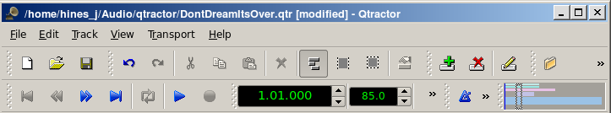
Figure 2: The Main Menu and Toolbar

The Track Data section is where most of the action takes place, and contains visual displays of the waveforms, or audio data This section is used for editing Clip objects and maneuvering around your Project Session.

Qtractor also has other useful windows, such as the Mixer window, and the Connections window. Both these windows can be opened using the F8 key for Connections window (Jack PatchBay), and the F9 key for the Mixer window. These items are also selectable from the View menu.

Two utility windows are additionally featured: the Messages window, specially suited for debugging, and the Files window, where audio and MIDI files are organized and selected on demand.

Dialog windows for editing session, track and clip properties are also accessible in their proper context, which will be discussed in their respective sections.

Finally, session and application configuration options are assisted through respective customizing dialogs: Buses, Instruments and Options.

8. Sessions

8.1 Understanding the Session Project

A Qtractor Session Project contains all the information about all your Clip Objects, placement of Clip Objects, Mixer setup, Plugins, Tempo, Time Signature and Connections Patchbay. When creating or saving a project, all this, and any related settings are saved on your hard disk within this Session Project file.

It is important to note that Qtractor Sessions are locked to a Session Project sample rate. This is dependent on the sample rate of the JACK[3] server running at the time the session is created.

Any attempt to convert non-matching sample-rate sessions will result in a recommendation warning message.

However, individual audio clip files are automatically converted on playback in real-time to the host sample-rate (via libsamplerate [8]). This method, while it works very well, is not the recommended method due to possible errors in the real-time sample rate conversion.Realtime sample rate conversion is also going to use quite a bit more valuable CPU resources.

Please note: It is NOT recommended you record audio tracks while in this sample rate conversion mode.

Rui Nuno Capela is working toward eliminating this shortcoming by taking control of JACK from within Qtractor, and restarting it using the Session's project parameters. This will ultimately reconnect any plugins, set the proper sample rate, etc. Until this feature is available, please follow the recommendations listed above.

8.2 Time Signature and Tempo

Although you may select any time signature and tempo for your Session, by present design Sessions can only contain a single constant tempo. Tempo must be regarded as a global setting of a Session. Qtractor does not presently support Tempo Mapping, but may eventually do so.

A new feature, which applies to existing audio clips, will reflect all tempo changes with a corresponding time-stretching effect. Time-stretching is thus applied in real-time at the buffering level, as a custom WSOLA algorithm based and derived from the SoundTouch [12] library.

8.3 Session Properties

To access the Session Properties, access the File/Properties menu item. Here, you can name your Session Project, set the Time Signature, Bars/Beats, Ticks/Beat, etc.
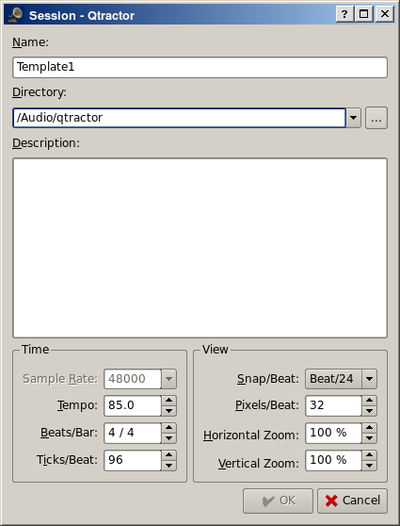
Figure 3: Session Properties Dialog

8.4 Session Options

Access the Options windows via the View/Options menu item. This window, and its tabs allows you to control the global parameters of Qtractor, and these settings are saved within your Session file.
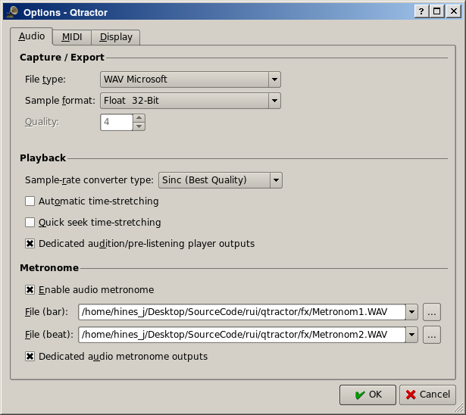
Figure 4: Options Dialog (Found under the View menu)

9. Files
Sound file selection is made available through a tabbed mini-organizer. Audio and MIDI file lists are kept separate on their respective tabs. Files can be explicitly added and grouped into a hierarchical tree list. Individual and multiple files can be drag-and-dropped from the desktop environment and within the provided tree list. This lists all the files which are referred in the working arrangement session. File items can be drag-and-dropped directly into the track window, thus creating new clips in the working arrangement. This is mainly used as a your audio/MIDI file data pool.
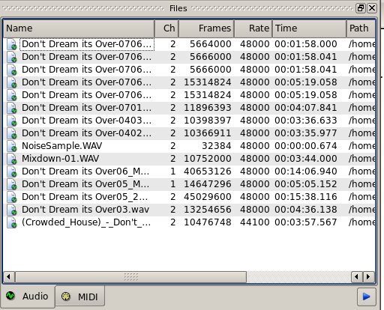
The Files Pool can also allow you to preview the files shown in the windows either by double-clicking the file name, or by click the play button on the lower right hand side of the Files Pool window.

Audio file format support is provided by libsndfile [5], and supports wav, aiff, flac, au, etc. Optional libraries provide support for both ogg and mp3 formats. libvorbis [6] (ogg) and libmad [7] (mp3). MIDI file support covers the usual SMF formats 0 and 1, through a native, home-brew implementation.

10. Clips

10.1 Clip Summary

Clip Objects are the elemental items of a session arrangement, and can contain either Audio or MIDI data. A Clip Object is merely a region of an actual sample or MIDI file. A Clip Object is also non destructive, and can be copied, truncated and time stretched as if it were actual audio/midi data.
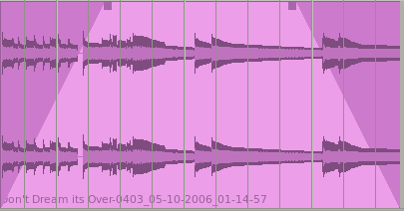
Figure 6: An example of an audio Clip with Fade-In and Fade-Out applied.

10.2 Clip Properties (Audio)
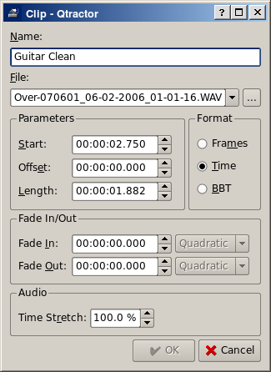
Clip properties include its label (Name), File path, start time (location), offset and length (in frames), fade-in and fade-out length (in frames) and Time Stretch percentage, respectively, from the start and end of the clip. Although fade-in and fade-outs are always displayed as straight lines, the actual audio volume (gain) and MIDI velocity effect can be opted to be of either linear, square or cubic characteristic, in as for an approximation to the logarithmic model of human ear perception.

Figure 7: Clip Properties

Clips are placed on tracks, either by importing audio and MIDI files as new tracks, or by dragging and dropping files into the track-view arranger window. Empty Clips may also be created by right clicking on a track, and choosing Clip/New. After being placed on their respective tracks, you may perform clip-region operations such as drag, copy, cut, paste, delete, truncate, fade in/out etc. Altering clip fade-in and fade-out is accomplished by dragging the handles (square boxes) on the top ends of any clip. A Clip may be split by positioning the playback head where you want to split it, right click the Clip, and choose Clip/Split. If you use this often, it is far more convenient to assign a keyboard shortcut to accomplish this task.

Most clip editing operations are accomplished through the usual mouse interaction, by first selecting one or multiple clips and/or regions, and applying the edit action upon the resulting selection. There are three selection modes available: clip, range and rectangular modes.
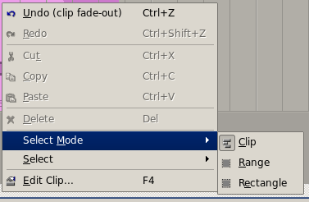
Figure 8: Demonstrates a right-click over a clip allowing for Mouse Mode Selection.

- In Clip mode, Clip Objects are selected as a whole with no sub-clip regions possible.
- In Range mode, Clip Object regions are selected on all tracks between a given time interval or range.
- In Rectangular mode, only the regions that fall under a rectangular area are selected, this means for adjacent tracks and clips only.

10.3 Clips and Tracks

Tracks may be armed for recording, making way for creating new audio and MIDI clip files with captured material. Tracks can also be muted and soloed on mix-down, which also applies when exporting. Most editing operations should be possible while playback is rolling (but not completely safe though; there are many procedural helpers, but not completely assisted with lock-free primitives, yet).

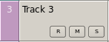
Figure 9: Track Functions: Record, Mute and Solo

MIDI Clip Objects are representations of a sequence of events of one single MIDI channel, as extracted from a SMF format 0 file or of one single track, as from a SMF format 1, either in whole or in part.

11. Engines and Buses
Qtractor is a fairly massive multi-threaded application. For instance, each audio clip has a dedicated disk I/O executive thread, which synchronizes with the master engine and, for all purposes, to central JACK real-time audio processing cycle, through a lock-free ring-buffer. These audio file ring-buffers are recycled (filled/emptied) at one second threshold, and has a maximum streaming capacity of 4-5 seconds of audio sample data. Smaller clips are permanently cached in a RAM buffer.

Audio thread scheduling is mastered and mandated through the JACK callback API model. MIDI clip events are queued in anticipation through one MIDI output thread, which feeds a ALSA sequencer queue, synchronized on one second periods to the JACK process cycle. A single thread is responsible for listening (polling) for MIDI input, and multiplexes all incoming events through record-armed MIDI tracks. Time stamping is done through the ALSA sequencer facility.

Looping is made possible through the audio file buffering layer, right at the disk I/O thread context. The same consideration is adopted for MIDI output queuing. JACK transport support is not an option, as playback positioning is constantly kept in soft-chase fashion. Audio frame relocation is accounted from successive JACK client process cycles (i.e. buffer-period resolution).

On this particular design, JACK and ALSA sequencer ports are logically aggregated as buses with respect to the audio and MIDI signal routing paths, functioning as fundamental device interfaces. Input buses, through exposing their respective input ports, are responsible inlets on capture and recording. Output buses are the main signal outlets and are responsible as playback and, more importantly, as mix-down devices.
Buses are independently assigned to tracks. Each track is assigned to one input bus for recording, and to one output bus for playback and mix-down. The assigned output bus determines the number of channels the track supports. Clips bounded to disparate multichannel audio files, for which their number of channels do not match with proper bus/track's one, are automatically resolved on mix-down. Figure 2 shows one typical signal flow block diagram.

By default, “Master” buses are automatically created at session startup, being stereo for audio (2 channels ports, auto-connected) and single port for MIDI (16 logically addressable channels). Bus ports are accessible for arbitrary connection to and from external client applications or devices, through the connections window interface.
Figure 10: Buses / Tracks signal flow diagram

12. Track View
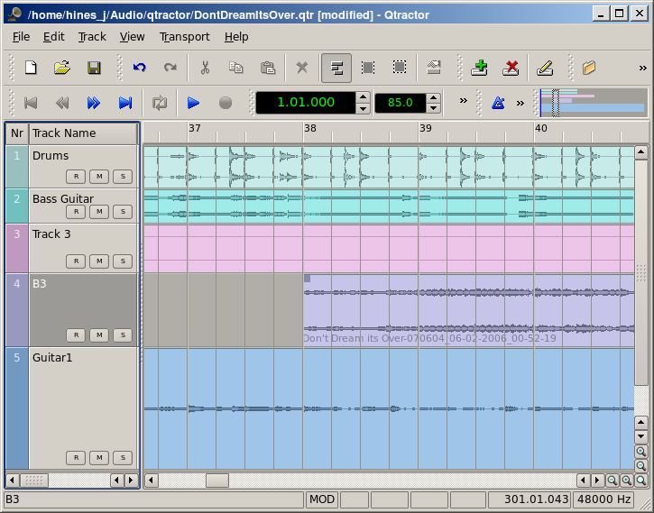
Figure 11: This is a snapshot of the main window with track layout.
Tracks are arranged as a sequence of one or more overlapping clips of the same file type, either audio or MIDI. The tracks window is the main application workspace, serving as a virtual canvas of a multi-track composition arranger. Most of the editing operations are made on this track list-view window.

The track list-view window has two panes, the left one displays the list of tracks with their respective properties and the center-right pane is the proper track-view canvas window where main multi-track composition and arranging activity is pictured and performed. As usual, tracks are stacked on horizontal strips and clips are layered on a bi-dimensional grid, in time sequence for each track strip. Time is modeled on the horizontal axis and pictured by a bar-beat scale ruler at the top of the track-view.

Clips may be conveniently aligned to discrete time positions, depending on the current snap mode setting. When not set to “None”, the snapping is always carried out to MIDI resolution, quantized to ticks per quarter note granularity.

Each track has its own user assignable colors for better visual identification. Audio clips are displayed with approximate waveform graphic, with peak and RMS signal envelopes as read from the respective audio file segment. MIDI clips are shown as a piano-roll like graphic, with note events shown as small rectangles, depicting pitch, time and duration.

All session, track and clip editing operations are undo/redo-able. Discrete view zooming and track vertical resizing operations are also available.

13. Mixer
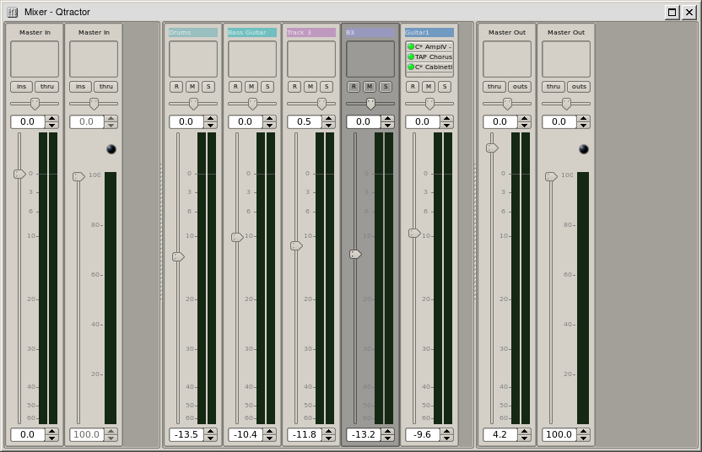
Figure 12: Full Mixer Window

The mixer window serves for session control, monitoring, recording and assistance in mix-down operations. The mixer is divided in three panes: the left accommodates all input buses, the center with individual track strips and the right for the output buses. Each mixer strip offers a volume and pan control and monitors each one of the respective buses and tracks. Audio strips also offers the possibility to chain plug-in effects (LADSPA [9]).

Monitoring is presented in the form of peak level meters for audio and note event velocity for MIDI, both with fall-off eye-candy. MIDI mixer strips also feature an output event activity LED.

Audio volume is presented on a dBfs scale (IEC 268-10) and pan is applied in approximated equal-power effect (trigonometric weighting). For MIDI tracks, volume control is implemented through respective channel controller-7 and system-exclusive master volume for output buses. MIDI pan control is only available for track strips and is implemented through channel controller-10. MIDI input buses have volume and pan controls disabled.

14. Connections Patch-bay
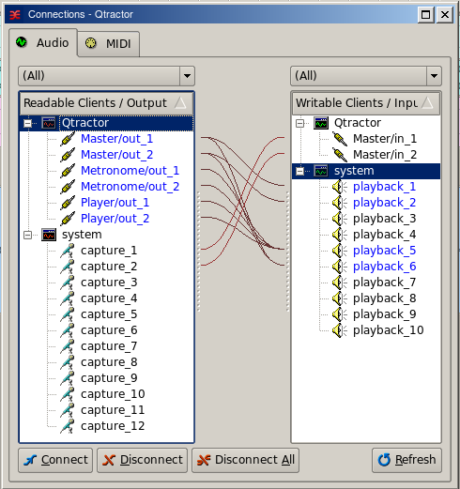
Figure 13: Jackd Connections Window
The connections window serves to establish the audio and MIDI port connections between the internal core layer input and output buses (ports), and the external devices or client applications. Incidentally the Connections window can also be used to make connections between external client application ports, either JACK clients for audio, or ALSA sequencer clients for MIDI. In fact, it almost completely replicates the very same functionality of QjackCtl [10]. All connections on the existing input and output buses are properly saved and restored upon session recall.

15. Audio Effects Plugins

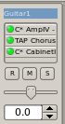
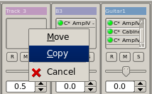
15.1 Summary

There are three types of Plugins supported within Qtractor. LADSPA, DSSI and VST. Plugin support is available for all audio input and output buses and for all audio tracks. All Plugin types are aggregated seamlessly as one single instance on a multi-channel context and can be individually selected, activated and moved within the plug-in chain order.

Also, you may drag-and-drop all plugin instances over the mixer strip channels. You can move, drag and drop inside the same strip or over to, and from any other. You may also copy plugins from one channel strip to another as well. A mini menu will ask if you want to copy or move the plugin. Individual plugin control parameters can be modified in real-time through provided dialog windows and maintained as named presets for re-usability.

15.2 LADSPA

LADSPA [9] has been the Linux audio plugin standard for many years. There are literally hundreds of LADSPA plugins available for Linux. LADSPA plugins give the user many standard options such as Eqs, Filtering, Reverb, Chorus, Amp and speaker simulation, etc.

15.3 DSSI

DSSI plugin support is available for DSSI effects plugins. DSSI Instrument plugins are not yet supported. You must have the core DSSI subsystem installed in order for this type of plugin to function. When DSSI is present, the DSSI-VST wrapper may also be used. This wrapper uses WINE (http://www.winehq.org) to allow a user to run native Windows® VST applications. The DSSI paths may be set within the Options dialog under the Display tab, or with an environment variable. (see section 15.5).
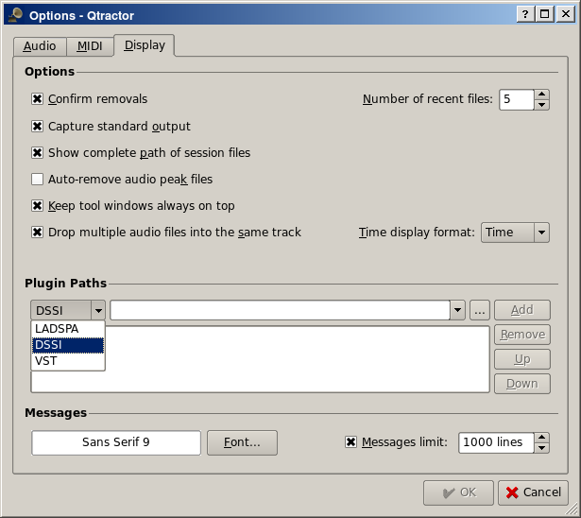

15.4 VST (Linux Native)

Native Linux VST plugin support is also available. Presently, there are only a few native Linux VSTs available, but more should be on the way soon, thanks to some aggressive ongoing projects.

Please see section 5.2 for complete information on building Qtractor with native VST support.

NOTE: Native Linux VST support does NOT include running of Windows® VST plugins. Please use the DSSI-VST wrapper when attempting to use this type of plugin, and make sure your Windows® VST plugins are located within your DSSI path environment variabe.

18. MIDI Instruments
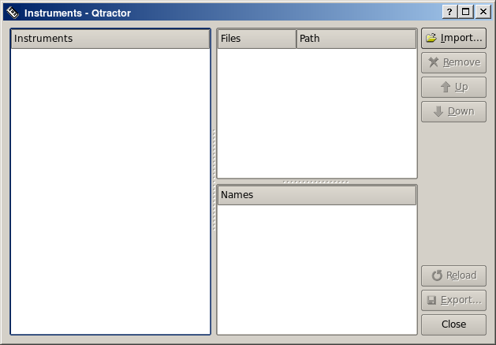
Figure 17: MIDI Instruments Editor

As a special feature, Cakewalk [11] instrument definition files (.ins) are natively supported, thus offering a convenient MIDI bank-select/program-change mapping for existing MIDI instrument patch names, and easier, intelligible selection of MIDI track channels.

19. MIDI Editor
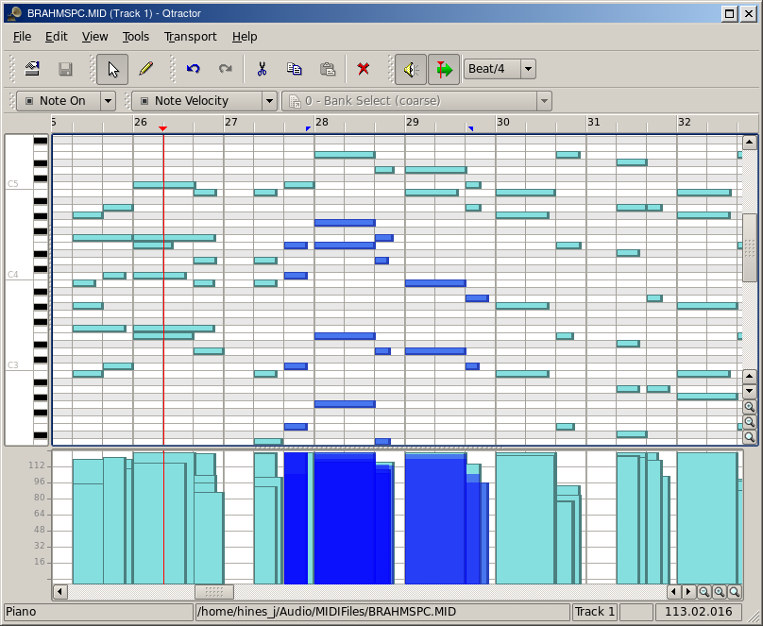
Each MIDI clip content may be readily edited under a dedicated and fairly complete piano roll MIDI Editort, with individual pitch, velocity and controller, editable trough the usual GUI operations such as: Multi-extended selection, drag-and-drop, move, cut, copy, paste, deletion of every event in the MIDI sequence is rightly accessible on the fly (Figure X).Figure 18: The MIDI Editor Window

Special home-brew tools for batch processing are also implemented and applicable to the any event selection: quantize, transpose, normalize, randomize and resize. All MIDI editing operations are available and processed in real-time, effective while playback. Several MIDI Editor instances may be active and open in any time, provided each one refers to its own clip.

All MIDI content may be saved as standard MIDI files (SMF Format 0 or 1).

20. Audio / MIDI Export
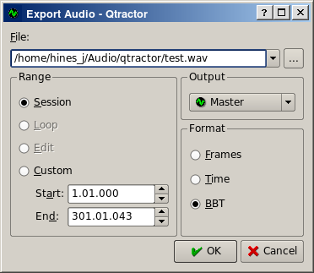
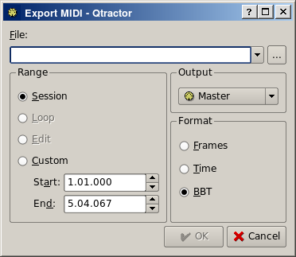
Figures 18 & 19: The Export Audio and Export MIDI Windows
All or part of the session may be exported to one audio or MIDI file. Audio export is implemented through the special JACK freewheel mode, thus faster than real-time, resulting in the complete and exact mix-down of selected audio material into a designated audio file of the opted format (wav, flac, au, aiff or ogg). MIDI export is just the same but for MIDI material only, resulting in the merging and concatenation of selected MIDI tracks and clips into a single MIDI file (SMF Format 0 or 1).
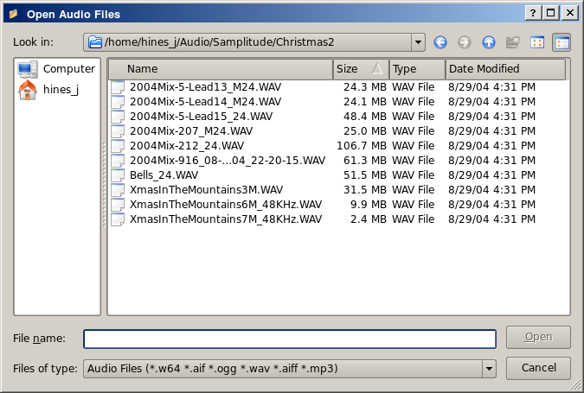
Figure 20: The Import Audio Window

21. Keyboard Shortcuts Editor
Keyboard shortcuts are useful for the power user, in such that it provides for a quick mechanism for performing often used commands quickly, without the use of your mouse.

Keyboard shortcuts may be customized to your preference by using the Shortcuts Editor. This editor may be found in the Help menu.
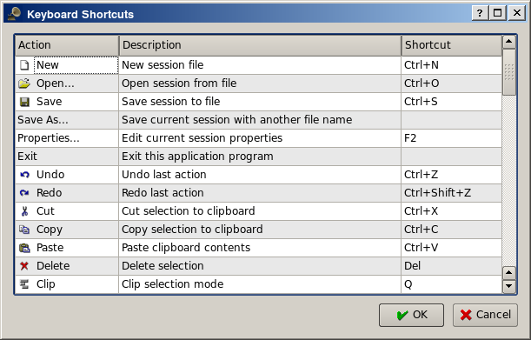
Figure 21: The Keyboard Shortcuts Editor

It is very straight forward in its use. Simply find the item you want to create a shortcut for, left click in the shortcut cell, and type on the key you wish to be assigned to that function. You will then see whatever key or key combination you chose appear in the context.

21. Menu Items

21.1 File Menu
New: Creates a new Session Project.
Open: Opens a previously created Session Project.
Open Recent: Contains a list of several of your last used Session Projects.
Save: Saves your current Session Project
Save As: Saves your current Session Project with naming conventions
Properties: Opens the Session Properties dialog
Exit: Exits the program.

21.2 Edit Menu
Undo: Will undo the last action.
Redo: Will Redo the last action.
Cut: Deletes and copies the item to the clipboard.
Copy: Copies the item to the clipboard
Paste: Pastes the item from the clipboard.
Delete: Deletes the selected item.
Select Mode: Selects the edit mode, one of Clip, Range or Rectangle.
Select: None, Range, Track or All
Clip: New, Edit and Split

21.3 Track Menu
Add Track: Will add either Audio or MIDI track.
Remove Track: Removes a track.
Track Properties: Calls the Track Properties dialog.
Import Tracks: Import either Audio or MIDI track.
Export Tracks: Export either Audio or MIDI track.

21.4 View Menu
Menu Bar: Will toggle whether the menu bar is shown.
Status Bar: Will toggle whether the Status Bar is shown.
Tool Bars: Toggles various Tool Bars on and off.
Files: Toggles whether the Files dialog is on or off.
Messages: toggles whether the Messages dialog is on or off.
Connections: Displays the Connections dialog.
Instruments: displays the Instruments dialog.
Buses: Opens the Buses Editor dialog.
Options: Opens the Program Options dialog.

21.5 Transport Menu
Backward:
Rewind:
Fast Forward:
Forward:
Loop:
Loop Set:
Play:
Record:
Metronome:
Follow Playhead:
Auto Backward:
Continue Past End:

22. Future Thoughts
As of its current status, there are many and rather fundamental functionality still missing that tear Qtractor apart from a finished product, let alone for the quest of its own goals. It's still a work in progress. In my own personal agenda priority, the following are the ones for taking care in times to come, in no special order. Check marks () indicate nearly complete, or completed features.

General
- DSSI and Native VST Plugin Support 
- LV2 Plugin Support
- Snap/Zoom Menu Accessibility
- Buffer/CPU% and Under-Runs Monitoring
- OSC or D-BUS Interface 
- Integrated Scripting (angelscript?)
- File/Session Project Management
- File Error Message Handling
- Redesigned Session Project Dialog
- Session Project Templates
MIDI
- JACK-MIDI Support
- MIDI SysEx Librarian
- MIDI Event List and Filter
- MIDI Editor Draw Mode
- MIDI Groove/Swing Quantize
- MIDI Controller Feedback
- MIDI Sync (MTC/SMPTE, MIDI Clock)
- Automation / Dynamic envelope curves
Tracks
- Auto Cross-Fading of Overlapped Clips
- Punch in/out and Loop Recording (eg. Takes)
- File Revision Resource Management
Clips
- Clip Split Command 
- Clip Locking, Muting
- Clip Plugins
- Pitch-Shifting of Individual Clips
- Paste Repeat Command
- Clip Linking
Mixer
- Mixer Presets
- Mixer Fader Groups
- Effect Aux Send/Returns (pseudo-plug-in)

23. Conclusion
As fundamental as is, Qtractor might be just some clone of earlier and existing software, being blatantly one of the Cakewalk's [11] Pro Audio series. It is however more than that, when regarded from the free open-source software development point of view, much like some cauldron framework, user-oriented, programmable, pattern sequencer, eventually targeted as a potential toolbox and workbench for easy, direct, live music-making and experimentalism

24. Acknowledgements
I am grateful to the free software open-source community in general and to the Linux Audio developers and users in particular, who dedicated their valuable time to the development and support of free audio and MIDI software, being Qtractor just one humble manifestation of such class of human endeavor.

Qtractor is free / open-source software; you can redistribute it and/or modify it under the terms of the GNU General Public License version 2 or later.

Qtractor logo/icon is an original work of Andy Fitzsimon, borrowed from the public domain openclipart.org gallery.

All or some product names mentioned in this document may be trademarks of their respective holders.

25. References
[1] Qtractor - An Audio/MIDI multi-track sequencer
http://qtractor.sourceforge.net/
http://sourceforge.net/projects/qtractor/

[2] Qt 4 - C++ class library and tools for cross-platform development and internationalization.
http://www.trolltech.org/products/qt/

[3] JACK Audio Connection Kit
http://jackaudio.org/

[4] ALSA - Advanced Linux Sound Architecture
http://www.alsa-project.org/

[5] libsndfile - C library for reading and writing files containing sampled sound
http://www.mega-nerd.com/libsndfile/

[6] libvorbis - Ogg Vorbis audio compression
http://xiph.org/vorbis/

[7] libmad - High-quality MPEG audio decoder
http://www.underbit.com/products/mad/

[8] libsamplerate – The secret rabbit code, C library for audio sample rate conversion
http://www.mega-nerd.com/SRC/

[9] LADSPA - Linux Audio Developer's Simple Plugin API
http://www.ladspa.org/

[10] QjackCtl – JACK Audio Connection Kit - Qt GUI Interface
http://qjackctl.sourceforge.net/
http://sourceforge.net/projects/qjackctl/

[11] Cakewalk - Powerful and easy to use products for music creation and recording
http://www.cakewalk.com/
ftp://ftp.cakewalk.com/pub/InstrumentDefinitions/

[12] SoundTouch – Sound Processing Library
http://www.surina.net/soundtouch/

[13] rncbc.org - My personal web presence, blog, forum and other mundane material
http://www.rncbc.org/

26. Tutorials
Coming Soon.

27. Appendix I: Debugging Qtractor
Although Qtractor is a mostly stable program, there could be problems that eventually show up. This short guide will explain to you how to build Qtractor with debugging code built in, making it easier to locate where the code exhibits problems.

Rebuild it all from scratch, with:
./configure --enable-debug && make
Enable core dumps in a shell session:
ulimit -c unlimited
From the same shell comman line, run the program until it crashes. You'll see something like this in the output when it happens:
Segmentation fault (core dumped)
Locate the dumped core file. Depending on your environmental settings it might be just named core or something like core.1234 (1234 is the process-id number of the crashing program) located on the last directory the program was current.
Load the core dump file into gdb
gdb ./qtractor /path/to/core
at the gdb prompt just enter:
gdb> bt
or
gdb> thread apply all bt

28 Appendix II: Changelog
Qtractor - An Audio/MIDI multi-track sequencer
----------------------------------------------

ChangeLog

0.1.2 2008-03-23 The Frantic Dame

- Session length fixed (yet again) while extend recording; also
improved follow-playhead switching while playback/recording.

- Whitespace sanitization gets leaner for all recorded filenames.

- Run-time SSE optimization detection has been improved while on
configure; additionally, IEEE 32bit float specific optimizations
have also sneaked in.

- SSE optimization is now featured over all audio monitoring, and
most specially on audio bus buffering, lowering the CPU burden a
bit while doing track and bus gain, pan, metering and mix-down.

- Fixed MIDI clip move into new track, preserving the original
channel, bank and program whenever possible.

- Fixed session cursor seeking, specially regarding overlapped
clips, once gain.

- The MIDI editor gets new menu access to current MIDI clip track
(see File/Track/Inputs, Outputs, Properties); selection of MIDI
events has also been improved, specially regarding overlapped
note events.

- Clip split command enters the stage (see Edit/Clip/Split) about
splitting the current (selected) clip at the current playhead
position (red cursor line). (EXPERIMENTAL)

- Creating new clips from scratch is now finally permitted (see
Edit/Clip/New...); additionally, the clip properties dialog is
now also allowing for changing the filename (and track/channel
as special to MIDI clips). (EXPERIMENTAL)

- Record armed tracks are now properly monitored and fed through
their own output audio bus on mix-down, which includes plug-in
effects processing (EXPERIMENTAL).

- The files widget get alternating coloured rows.

- VST plug-in preset values are now being restored properly;
individual parameter changes are now being queued for the
also convenient undo/redo command pattern.

- Some audio clip buffer-sync tweaks have sneaked in, improving
and fixing the rendering of full-overlapped, integrally cached
and/or offset clips altogether.

- Stuffed one primordial shot on XInitThreads() at the main head,
and let native VST plug-ins start behaving as they should, or
not; this might be in fact problematic and dangerous for people
who won't ever try the JUCE based plugins as from JUCETICE
(http://www.anticore.org/jucetice), due to some broken locking
mechanism in xcb; thanks anyway to mighty kRAkEn/gORe@JUCETICE
for this precious hint and from who knows best.

- True deterministic session length update has due fixed.

- Track menu has new accessible actions:
Track/Inputs - show current track input bus connections;
Track/Outputs - show current track output bus connections;
Track/State/Record - arm current track for recording;
Track/State/Mute - mute current track;
Track/State/Solo - solo current track;
Track/Navigate/First - make current the first track;
Track/Navigate/Previous - make current the previous track;
Track/Navigate/Next - make current the next track;
Track/Navigate/Last - make current the last track;
Track/Move/Top - move current track to top;
Track/Move/Up - move current track up;
Track/Move/Down - move current track down;
Track/Move/Bottom - move current track to bottom;

- View menus have new accessible actions:
View/Zoom/In - horizontal and vertical zoom-in (Ctrl +);
View/Zoom/Out - horizontal and vertical zoom-out (Ctrl -);
View/Zoom/Reset - reset both zoom levels to default;
View/Snap - select current snap-per-beat setting;

- Plug-in forms don't auto-open on session reload anymore.

- Keyboard shortcuts icon item (Help/Shortcuts...) sneaks in.

0.1.1 2008-02-16 The Futile Duchess

- After some great user demand, keyboard shortcuts are finally
configurable, as found provisionally under Help/Shortcuts...,
for the main application menu and for the MIDI editor as well.

- Debian package gets SSE optimization disabled as default.

- At least some transport actions get to be non auto-repeatable
when pressed for much too long, as Play and Record, avoiding
the tumbling imposed from the keyboard.

- For the first time ever, jackd auto-start is now allowed (!).

- OSC service support through liblo gets optional at configure
time, now leading the way to proper DSSI plug-in hosting.

- All plug-in widget controls count are now capped to one hundred.

- Plugin paths setup is now made available on the options dialog,
overriding each of respective default settings, as implicit from
the LADSPA_PATH, DSSI_PATH and VST_PATH environment variables
(see View/Options.../Display/Plugin Paths).

- Clip fade-in/out lengths are now kept relative to tempo changes
and also to clip offset and length changes (clip resizes).

- Automatic time-stretching for all audio clips when session tempo
changes, may now be disabled/enabled as a global session option
(see View/Options.../Audio/Playback/Automatic time-stretching).

- Double-clicking on an empty area (de)selects all clips on track.

- MIDI capture (record) quantization is now an option, possibly
handy for some jerky performance musicians, as the one found
in myself ;) (see View/Options.../MIDI/Capture/Quantize).

- The global options dialog (View/Options...) has seen its Display
tab page being moved back and to the right.

- Major rewrite of the plug-in infrastructure, adding primordial
support for DSSI and native VST plug-in flavors.

- Drag-and-drop of plug-in instances are now allowed intra- and
inter-mixer strip chains, either on tracks or buses.

- Turning track record off while recording is rolling was leaving
the session in a inconsistent recording status, now fixed.

- A random but instant crash upon audition/pre-listening player
onset was hopefully fixed.

0.1.0 2008-01-05 The Frivolous Debutante.

- Audio clip time-stretching makes its debut, with code adapted and
refactored from the SoundTouch library, under the (L)GPL umbrella.

- New "Options.../Audio/Playback/Quick seek time-stretching" global
option, providing a quick seek mode (hierarchical search) while
doing all audio buffer time-stretching.

- Changing session tempo will automatically apply the corresponding
time-stretch percent factor to all in-place audio clips. Audio
clip dialog also includes a new time-stretch property setting.

- Tempo changes are now affecting clip offsets correctly, keeping
the clip offset constant in time units (ticks), as are clip start
and length properties already.

- Mixer splitter sizes are now properly saved/restored when hidden.

- Extended multi-selection is now featured on the files widget; all
drag and drop functionality has been almost completely rewritten.

- SSE optimization is now enabled where available (via configure).

- Options for having separate dedicated ports for the audition/pre-
listening player output, audio metronome output, MIDI control
input/output and MIDI metronome output, are now in place.

- A brand new subtle option sneaks in, affecting the drag-and-drop
of the main track-view: View/Options.../Drop multiple audio files
into the same track, whether to drop multiple external files into
new or existing track as concatenated audio clips.

- The audio metronome makes its debut as an alternative to the MIDI
existing one; parameters include bar and beat audio sample files,
accessible from the View/Options.../Audio/Metronome dialog.

- Files widget action refactorization; the files context menu gets
its due item icons and a new menu item for direct audio player
accessibility.

- MIDI time resolution changes (ppqn, ticks per beat) now tries to
keep all session MIDI clip times unchanged as far as possible.

- MIDI channel volume and panning control change events, CC#7 and
CC#10 respectively, are now rendered unfiltered on playback.

- First rendition of the long due implementation of an audition or
pre-listening audio player is now in place; the files window got
this new play/stop control button on its lower-right corner.

- Actual instrument definition note (keys) and controller names are
now in effect on the MIDI editor, whenever applicable.

- Fixed instrument bank selection method, "Bank MSB" (2), which was
broken enough to never send the correct bank number.

- Mouse-wheel horizontal scrolling is now accessible on every view,
while pressing a modifier key (Shift or Ctrl).

- New auto-backward transport option: when enabled the playhead will
be reset backward automatically whenever transport stops playing.

- A suicide-crash has been fixed while invoking the bus dialog from
the respective mixer bus strip context menu.

- Master (default) buses are always set to Duplex mode, being now
an enforced update policy while on the Buses dialog.

- A stupid lockup bug (infinite loop) was spotted on the track bus
assignment method and squashed (thanks, lexridge).

- New keyboard shortcuts for toggling the Connections tool (F8) and
the mighty Mixer tool (F9) windows.

- Avoid showing a context menu while right-clicking on time rulers.

- Audio clip waveform drawing gets additional closing points.

- It is now possible to change the length/size of a clip by dragging
its left or right edges, while in the main track-view. Shift+drag
will also time-stretch to the resulting audio clip length.

- Another off-by-one mistake was corrected, which was causing audio
clips to go out-of-sync on loop turnover boundary; also changed
the loop turnaround strategy, now honoring already cached periods.

- A race-condition has been mitigated in the audio-buffer thread,
that was exposed and lead to sudden application freezing upon
changing some composite audio clip commands.

- Take absolute audio peak values only, making peak files a little
bit shorter and hopefully faster to load and draw as waveforms.

0.0.9 2007-11-30 The Adolescence Prime

- Drag-and-dropping of MIDI files without specific track or channel,
into existing tracks, is now rejected. The drop operation is now
allowed on the track-view blank area only, meaning the same as the
complete MIDI file import into session.

- Record actual MIDI clip length to last play-head position,
instead of time of last event in the recorded sequence.

- Connections item lists gets properly sorted, as intended.

- Clear connection persistance once an explicit discconnection is
issued on any of the (intrinsic) bus ports.

- MIDI output buses now get the panning slider to spit out some
GM system master balance (sysex) messages, being now enabled.

- Mouse hovering on the clip fade-in/out handles, while in the
main track-view, gets its long due cursor pointer feedback.

- Fixed a off-by-one boundary issue on MIDI clip event playback,
which were enqueuing duplicated MIDI events on every read-ahead
output thread processing cycle (1 sec).

- Transport menu and toolbar are now featured on the MIDI Editor.

- Use actual session name when asking to save changed session.

- Transport loop setting keyboard shortcuts swapped: Ctrl+L will
set the loop immediately, and Shift+Ctrl+L will toggle on/off.

- Changing MIDI event duration may now affect MIDI clip duration.

- Alternate sharp-note color lines have returned to MIDI Editor
canvas, as was the shadow color marking the end of MIDI clip.

0.0.8 2007-11-12 The Twelfth Tight

- Bus context menu is now accessible from respective mixer strip.

- Fixed a subtle crash-suicide issue when invoking the bus dialog
with a double-click over the corresponding mixer bus strip; also
fixed the sloppy ganguing mistake when changing mixer bus gain
(volume) and panning values.

- MIDI Omni mode (sort of) makes its entrance as a new MIDI track
property, meaning that is now finally possible for the capture of
any unfiltered MIDI channel event, without regard to the current
channel assignment, which still applies for playback purposes.

- Audio (pass-)through has been also implemented, now being a common
and consistent property of both audio and MIDI buses, provided
those are set in duplex mode (input and output).

- Re-touched follow-playhead and continue-past-end tool icons, again
to be a bit softer and not so bright as to hurt someones eyes.

0.0.7 2007-10-31 The Eleventh Tower

- Suspend auto-follow-playhead while dragging or moving content over
the main track and midi editor views; re-touched follow-playhead
and new continue-past-end tool icons.

- Playback is now forced complete full-stop whenever play-head goes
behind the current session length and/or loop-end and the newer
"continue past end" option is enabled from transport menu.

- Tool/child windows position and size preservation fixed.

- MIDI (pass-)through has been finally implemented, after several
kind requests, it applies as a property of duplex-mode MIDI buses;
this new setting is configurable from the View/Buses... dialog;
also from respective new input bus mixer-strip button; when enabled,
implies all incoming MIDI events at the input bus will pass-through
unchanged to the corresponding output bus, as found useful just for
direct monitoring one's performance without the help of any extra
circumvent or kludgy connections.

- Mouse cursor shape changes accordingly while hovering in header
time-scale rulers, both in main track-view and MIDI editor.

- Track-view clipboard paste action has been refactored, with the
user interface consistent with the same functionality featured on
the MIDI editor: the clipboard selection being pasted now floats
at the mouse pointer and can be moved around before placed into
its final position, either with the mouse or keyboard arrow keys.

- A unitialized member variable bug affecting all MIDI clips has
been discovered and squashed; this one has been lurking for quite
some time and was causing wrong clip editing results, specially
when tempo or meter differs between session and the MIDI file.

- Keyboard step-moving is now allowed while pasting in MIDI editor.

- Track-view clip selection can now be drag-moved into the void
(bottom) view area creating brand new tracks automagically.

- Losing focus resets all current keyboard step-moves in progress,
affecting the main track-view and all MIDI editor as well.

- As done before on the MIDI editor, the main track-view current
selection may be step-wise moved using the keyboard arrow keys
and the enter/insert keys for final placement; horizontal step
movement is quantized according to current snap setting; vertical
key-step movement is only allowed to selected clips belonging to
one single and the same track.

- Immediate session loop settting, accessible from the main menu.

- Track properties dialog gets fixed again in its auto-size treat.

- Another audio-buffer thread bug was scrubbed off, which was
causing spurious and audible garbage on certain loop workloads.

0.0.6 2007-10-09 The Tenth Commencement

- A bit more of precision is achieved over the metronome regular
ticking and both the audio and MIDI monitor meters.

- A rudimentary MIDI metronome is now in place; parameters, like
MIDI channel, bar and beat accent note, velocity and duration,
are readily configurable from the main menu, View/Options...
/MIDI/Metronome dialog.

- Track properties dialog now gets tightly auto-sized, depending
whether its an audio or a MIDI track.

- MIDI clips are now auto-extendable when adding or moving events
beyond the clip length and while in the MIDI Editor, of course.

- MIDI editor current selection can now be step-wise moved using
the keyboard arrow keys and the enter/insert keys as for final
placement; horizontal step movement is subordinated to current
snap per beat setting, no less than unity; vertical step moves
are obviously quantized to the next semitone.

- Get configure to try and detect the correct qmake location and
insert it the search order, so let the qt4 tools take precedence
when --with-qt option is given and older qt3 ones coexist and
are found located ahead in the PATH.

- Drifting correction on audio and MIDI engines was seriously
infected in some kind of snafu conception, as evidence lead
to even worse drifting being detected to much of great despair,
specially after recording and/or bouncing audio tracks from
MIDI sequenced material. Credit must certainly go to Christian
Schoenebeck on splatting this sloppy one on the face.

- MIDI editing actions while playing now get immediate feedback;
this was possible to some internal interface redesign of all
MIDI editor accessory classes, making the MIDI clip now being
the main editing target object instead of just the MIDI event
sequence as it was previously.

- Simple as it could ever be, the build executive summary report
is now given on configure.

- The internal decoded frame list for MPEG 1Audio Layer III (mp3)
audio files (ie. via libmad) has been made one-time cached as
global shared objects, benefitting from the fact that the list
is always completely (re)built during the peak file computation,
and thus speeding up all frame accurate access operations (seek)
over this specific audio file format.

- More eye-candy is sneaking in the MIDI editor: there's new view
options on the View menu: Note Color and Value Color, affecting
note event colors according to pitch and/or velocity.

- New view option on the MIDI editor: on menu View/Note Duration
switches whether events are shown proportional to their durations
or as simple vertical candlesticks.

- New snap-per-beat divisors are now available (Beat/3, 6, 12, 24
and 48), giving support for triplets for the very first time
(after a heads-up suggested patch from Marko, thanks).

0.0.5 2007-09-08 The Ninth Hitch Nail

- MIDI edit tools (quantize, transpose, normalize, randomize,
resize) are all functional and ready for experimentalism;
gets in its own top-level menu and form with named preset
store and recall functionality (EXPERIMENTAL).

- Main form backward and rewind transport actions are now being
immediately enabled when playing from the session (zero-time)
start position.

- Audio and MIDI export sneaks in and in form and accessible
from the main Track menu (EXPERIMENTAL).

- MIDI track channel is now properly set on session (re)load;
track background color changes was missing the alpha setting.

- The mix-down buffering was fixed again, now taking multi-track
overlapping clips into consideration (was a lot more broken
since the recent glitch-looping fix).

- Dirty MIDI clip editing control has been fixed but still
somewhat hacky nevertheless.

- First attempt on solving a nasty MIDI editor bug, which was
quietly and severely crippling MIDI files while saving offset
edited clips.

- Session loop (re)setting is finally now an undoable command.

- Yet another insidious bug has been swept away from under the
carpet: once again on audio looping, some astonishing old and
crappy session cursor seek-backward statement was lurking to
be laid off. Gone now, simply as it is, growing old on this :)

- A tremendous bug has been fixed: audio looping is now a little
more glitch-free as the mix-down buffering was badly broken
even since its primordial implementation. Rejoice.

- Minor improvements on track-view cursor updates and visual
tracking while recording.

- MIDI editor windows get their keyboard accelerator/shortcuts
back in business, whether opted as tools always on top or not.

- The infamous "Keep tool windows always on top" global option
is now infecting the Connections, Mixer, Plugin and MIDI Editor
window instances with no probable regrets. To be used with
discretion, of course.

- Session update/initialization gets it clean on startup.

- Range selection action (Ctrl+R) is now back in business with
the added bonus of being accessible from all MIDI editor
instances too.

- Common edit-head and tail cursor positions are now under common
control and display from all MIDI editor instances; the session
loop-start/end points are now also shown on every time-line and
share the same control behavior across all MIDI editor instances.

0.0.4 2007-07-19 The Eighth Wanderer

- Main toolbar tempo spin-box gets loose from keyboard change
tracking (Qt >= 4.3); custom spin-box compilation fix for
Qt 4.1.

- Illusive but nasty Connections/Patchbay item tooltip crash bug
has been hopefully fixed (Qt >= 4.3); QComboBox::editTextChanged()
signal replaces old QComboBox::textChanged().

- Combo-box setup history has been corrected on restore, which
was discarding the very initial default (factory) contents.

- Make debian package build depend on libqt4-dev; win32 console
flag is back to qmake project file.

- MIDI instrument selection (e.g. on track form) gets fixed and
improved.

- Sorting method for the connections port list has been refactored;
potential crash bug fix on connections sorting method.

- Messages class accessor methods constness fix.

- Got rid of some autoconf redundand thingies on configure;
late debian changelog update.

- Desktop categories update: AudioVideo.

- README correction.

0.0.3 2007-06-23 The Seventh Draught

- Crash fix on the connections widget, was a matter of refactoring
the refresh/clear slots.

- Help menu added to MIDI editor form (redirected and same to main
form anyway).

- Clip properties form gets its proper sanity check, querying any
existing clip editor whether its safe to apply the new settings.

- Mixer sliders get their long due valued correction, hopefully.

- Transport backward and play/stop are now made accessible from
the MIDI editor widget, through their keyboard accelerator
shortcuts (backspace and space, respectively).

- Transport actions (play, rec, rew and ffwd) are now kept stable
on a single point, instead of being scattered all over the main
form code; transport visual feedback might get affected,
specially regarding the MMC processing.

- Application icon is now officially installed
into ${prefix}/share/pixmaps.

- Spec file is now a bit more openSUSE compliant; just made RPM
requirements as exigent as the new debian ones.

- Paste cursor is now properly preserved after leaving MIDI editor
views.

- Amazingly why this was not spotted before, the main application
logo-icon has been downscaled to the 32x32 pixel standard icon
size.

- MIDI clip editor clipboard gets singleton status and is now
shared on all MIDI editor instances. Similarly to the main
track-view, shift/ctrl-left-clicking on the MIDI editor views
sets the current session play-head position.

- A desktop entry file has been included on install, at last.

- Clips in main track-view get more info in the form of tooltips.

- Major rounding fix to time-scaling and most specially on all
those internal MIDI I/O methods.

- Extended range selection from the time-ruler and key-list
headers is now possible by click-and-drag the mouse pointer.

- Play-head cursor is now also displayed and/or set position
on all open MIDI clip editors time line view. As in the main
application form, a new local follow play-head option is also
featured on the MIDI editor view menu and toolbar.

- All MIDI file save operations are now logged to main messages
and files are added to the main files list view.

- Initial debianization.

- MIDI capture/record file format (SMF Format 0 or 1) is now
an user option, introducing the new MIDI tab on the global
View/Options dialog.

- A bad old-time session cursor glitch has been apparently fixed.

- Make sure the generic clip properties form is modal.

- Major rewrite and adaptation to the session time-scale properties,
making its way for a brand new command instance: the session-tempo
command.

- Changing the snap-per-beat combobox value on the main window
toolbar does not make it as an undoable command anymore.

- Long due MIDI clip editor integration has come to reality.

- Major rewrite on the MIDI sequence file read/write methods,
in preparation to the coming MIDI clip editor.

- Status-bar session length label now gets rightly updated,
while extended recording, of course.

- Clip properties fade-in/out lengths, gets their old due
constraints.

- Main transport time display is now an editable custom spin-box;
the Tempo (BPM) spin-box has seen new colors (green on black).

- Transport time display format option adds the new choice of
absolute frame number, alternative to previous time and BBT.

- The frame-time based spin-boxes, on the clip properties form,
were replaced with a new custom one, allowing for alternate
frame, time and bbt input/display formats.

- Time-scale helper class has been introduced.

0.0.2 2007-05-26 The Sixth Lord

- Audio/MIDI connections gets slightly refactored, contributing
for whole robustness, specially in case of incidental engine
shutdown.

- Mixer window gets a minimum default height bump.

- Clip fade-in/out type changes have been properly fixed.

- Complete refactoring of the command class pattern, making it
now derived from QObject and not having a reference to the
main form anymore.

- Inoperative context menu event handler has been removed from
the track-view.

- MIDI sequence note-on event tracking now uses faster QHash
class, instead of original QMap.

- Off-by-one bug fix on MIDI track write method, while parsing
co-incident note-on/off events in the wrong order and thus
leaving note events with an invalid (zero) duration; obviously
affecting MIDI recording in very special circumstances.

- Minor and rather innocuous drop at this time in the MIDI event
class structure: the flags member field.

- Port connections now get their lines correctly drawn; strangely
enough, the connection lines were being painted only for the
parent client items, probably since the Qt4 migration (aka.
Halloween files).

- Early clip editing is in place (clip name, start, offset and
length parameters, fade in/out length and type).

- Some menu item text capitalizations.

0.0.1 2007-05-07 The Filthy Fifth

- Newer JACK 0.105.0 seems to bitch, probably correctly, about the
return value of the process callback. Make it to bitch no more by
ensuring the JACK client is always issuing the innocuous 0 (zero)
return value.

- Important fixes have been issued, affecting MIDI recording: MIDI
sequence zero-time event insertion; MIDI file pending note-off
processing on write-track method.

- Qt4 migration complete.

0.0.0 2006-10-31 The Halloween Files

28 Appendix III: User Documentation Changelog
0.1.2 2008-03-16

- Updated Figures 4, 5 and 7 with updated screen snapshots.

- Updated text on Adding new Clips, and Splitting Clips.

- Changed formatting from US Letter to A4.

- Added an Appendix 2 for the Qtractor Changelog.

- Added an Appendix 3 for the Manual Changelog.

